Brawling Robots Concept Document

# Description

An action game that involves combat robotics. To win the player must defeat the opponent either by judge’s decision, immobilization or destroying the other robot. The player can fight either AI robots or other robots in local multiplayer.

# Project Inspirations

## Robot Arena 2

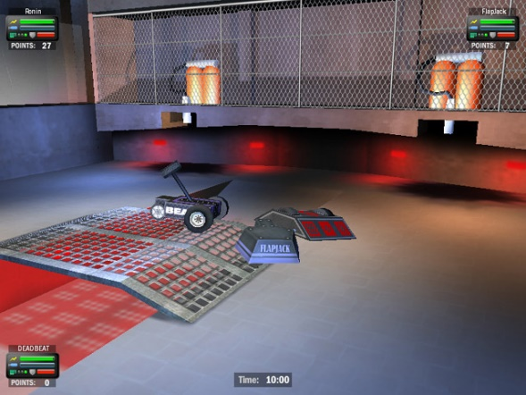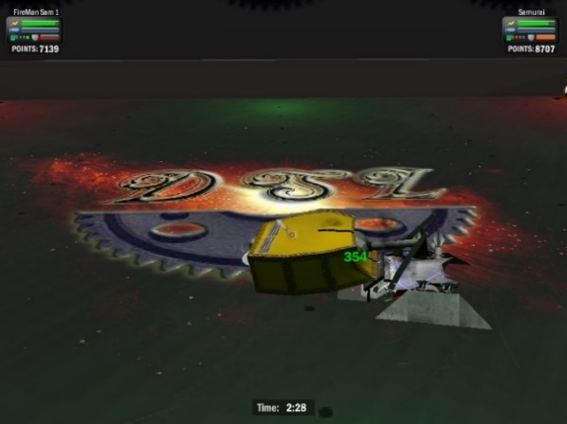

An action game released in 2003 that allows players to create their own combat robot and fight. To win the player must destroy the opponent’s robot or immobilise them. The winner of a match when the timer expires is determined by the player with the most damage points. It is online/offline multiplayer and AI robots. Additionally, AI robots can have different playstyles. This game is a huge inspiration with its AI, destruction & physics leading to endless fun. Something I want to replicate and improve upon.

## Robot Wars Arenas of Destruction & Robot Wars Extreme Destruction

Robot Wars Arenas of Destruction:

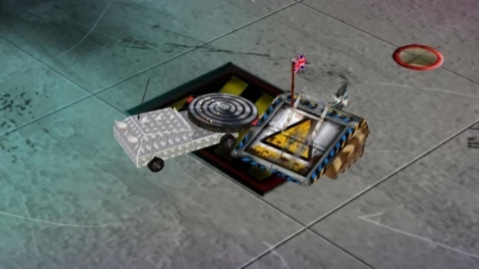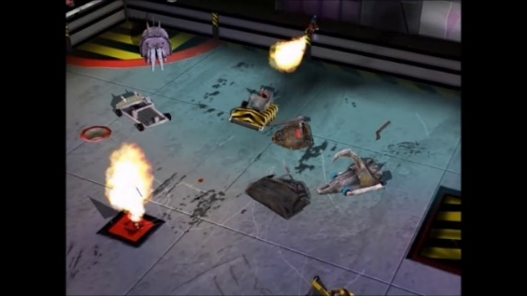

Robot Wars Extreme Destruction:

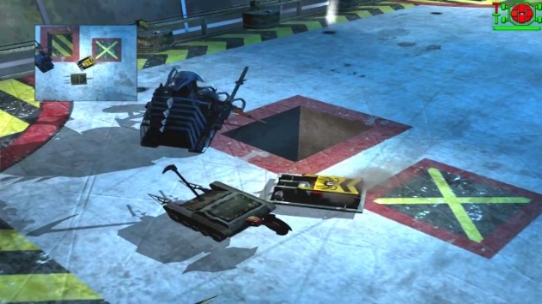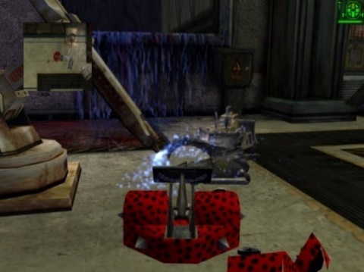

Based on a popular show called “Robot Wars” which aired in the late 1990s and early 2000s. Much like Robot Arena 2, the player can make a robot to fight but also use pre-existing robots from the show. The main differences compared to Robot Arena 2 are:

* Earn cash from tournaments
* Completing tournament unlocks components and pre-existing robots.
* Must purchase components and pre-existing robots.
* Less sophisticated robot builder
* Poor physics
* Judging system - Tiebreaker at the end of match consisting of style, control, damage, and aggression. The winner will be the player with the highest overall score.

Game modes:

* Mad bomber – Ensure you do not have the bomb upon timer expiry and be the last alive.
* Sumo – Push the other robot off the sumo arena (small, elevated platform).
* Endurance – Battle 7 robots one at a time without any repairs.

The games’ inspired my project with its simplicity and arcade feel. It is simpler than Robot Arena 2 in some ways which I enjoy.

## Robot Rumble 2.0

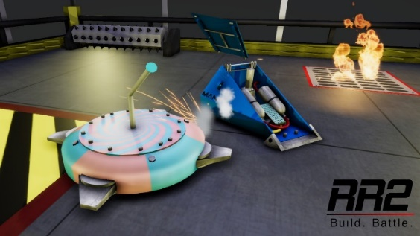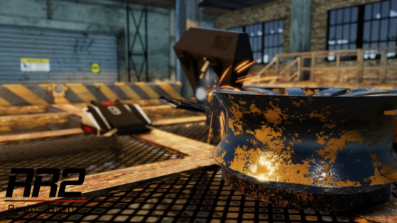

A game in development, made in Unity and looks promising for fans of combat robotic games as it is supposed to be a simulation like Robot Arena 2 but new and improved. It is inspiring because it has helped me decide which engine I should use for this project and a big reason for creating this project. Furthermore, I inspire to make a similar damage system with panels and weaponry falling off. Which requires me to create my own assets.

# Aesthetic

## Visuals

The visuals for gameplay will be basic as I will have to model robot parts myself. This gives me plenty to do and I do not think I will have time to do any fancy textures, which leaves me to use mostly solid colours for robots.

## Animations

Animations will primarily be used for the UI and the arena. This is because the robots are physics-based so there is not anything to animate there. While, the UI can be animated to tween, fade and much more. Also, the arena hazards could be animated as they are stationary.

## Audio

Non-diegetic audio. Audio will not rely on distance to adjust the volume of audio cues. As the game includes destruction of robots, the audio will be somewhat unpleasant. The sound created will depend on the impact, material, and weapon type.

## Music

The music genre I will be using for my game is Rock, but more specifically Metal. I personally believe it helps with the game. It was used on the “Robot Wars” show.

# Features

* Single player/local multiplayer
* Controller support
* AI
* Destruction
* Immobilisation
* Judge’s decision

# Mechanics/Systems

## Destruction System

The main system of the game which allows the player to destroy the opponent’s robot. Damage can be dealt to other robots by using the robot’s active weapon. All robots will have components and parts that can be damaged or broken, which will affect the match outcome. The amount of damage done depends on the weapon type and other factors such as the environment and material.

## Immobilisation System

During battle, it is expected that a robot will not function properly. To ensure a match does not drag on with shuffling robots they will be counted out and deemed immobile. A robot is classed as immobile when they cannot move a certain distance from their current location with “controlled movement”. The distance they must travel to be deemed mobile is roughly the size of the robot itself.

## Judging System

If multiple robots are still mobile at the end of the match, we need some sort of tiebreaker. So, we score each robot in three categories, damage, control, and aggression. Each category will be rated up to 100 points. Destroying/damaging components off other robots will earn damage points. Staying on the attack will earn you aggression points and operating your robot well will earn control points. Being unstable for periods of time may lead to point deduction in control.

# Diagrams

## Destruction System

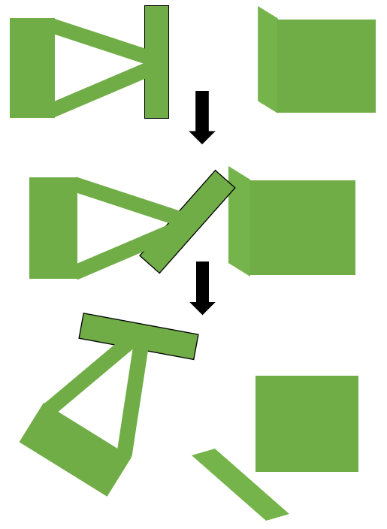

## Immobilisation System

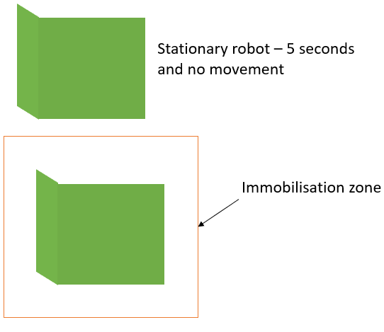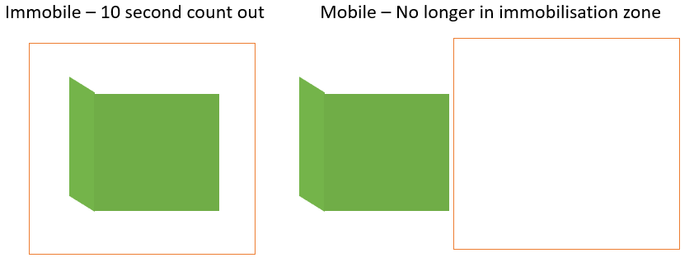

# Player Motivation

Action – The game is an action game and players who like action games are most likely to play the game. Every battle the player enters should be full of action.

Achievement – There is no real end goal for the player, but the player might seek to set themselves challenges such as beating the AI despite being at a disadvantage.

# Mood

The game is not supposed to be serious, although it may be quite competitive. I want to try and bring a party game vibe to this project, but this could be subject to change.

# Robots

Each robot I create should have a different style of weapon. Each robot will have their strength and weaknesses.

## Launcher

A robot type used to toss robots into the air. Effective in arenas with smaller walls as they can toss the robot out of the arena. Furthermore, they are effective against robots that are not invertible.

## Axe

Weaponry with typically 180 degrees movement. Designed to attack the top armour of robots where the armour is most likely weakest. Can also disable weapons by axing chains, belts, and other mechanisms.

## Vertical Spinner

A robot with spinning mass that is rotating in the vertical axis. Most of them pack-a-punch while having excellent defence. They are currently seen as the meta but for my game, the vertical spinner I design would not be so one-sided.

## Horizontal Spinner

A robot with spinning mass that is rotating in the horizontal axis. Typically hold the most kinetic energy which is why it will do the most damage out of the robots I am making. There is downside usually being that they do not have much armour. They have the strongest offense but the weakest defence.

# Miro

<https://miro.com/app/board/o9J_ktK0pSc=/>

# MoSCoW

Must Have

* Melee game mode
* Single player & local multiplayer
* Basic destruction

Should Have

* Various robots to choose – Each have a different weapon type
* Numerous arenas with hazards
* Controller support – Easier to have multiple people playing
* Judging system – In case of a tiebreaker, the player’s performance needs to be judged to determine the winner.
* AI

Could Have

* More robots – Cluster, saw, crusher, lifter, thwack, front-hinged flipper
* Configurations for robots – Maybe changing out wedge, or other attachments
* Other game modes – such as annihilator and tag team terror and sumo
* Tournaments – Various formats for the player to enter, might even earn something at the end.
* Robot builder – Allowing the player to create their robots would be an awesome feature. Although, the likeliness of this feature being implemented is low because of its magnitude.
* Profile system – The player can have a profile to store their progress.
* AI playstyles – Depending on the robot type would determine the playstyle of the robot.
* Advanced destruction – Depending on how far I get with my studies, I would like to go more in-depth and not have parts break off once past a certain damage sustained threshold. Maybe have the parts’ material crinkle or bend, depending on what is applied.

Won’t Have

* Networking – Unknown territory for me. Furthermore, this feature isn’t something you can just create and having no experience doesn’t help. Finally, I already have enough to do.

# Default Controls

Player 1

Movement - WASD

Weapon - Space

Player 2

Movement – Arrows

Weapon - Enter